**PROJECT PROPOSAL GUIDELINES** **INFO 4302**

**PROPOSAL FOR PROJECT DEVELOPMENT**

**PROJECT TITLE :**

**FOOD MAKER ASSISTANT APPLICATION**

**GROUP NAME:**

**FOOTSCRAY**

**STUDENT NAME:**

**AHMAD IZZUDDIN ZUHRI BIN ZAIDIN**

**MATRIC NO:**

**1518073**

**PROPOSAL FOR PROJECT DEVELOPMENT**

**1.1 INTRODUCTION**

The application is about to provide the users a list of dishes which can be chosen to cook. It also provided with the information such as list of items needed for recipes, the amount of items, and duration to cook to produce better quality of taste. Users are given step by step guide on how to prepare a dish they wish to cook that can be choose from the list of recipes provided. The application not only gives users the instruction but also provided the video of the best chef to cook the dishes based on the recipe. Users can refer the video that have been provided in the application to get thing more clear.

**1.2 PROBLEM DESCRIPTION**

**1.2.1 Background of the problem**

This application will develop based on mobile application. The application can be use by anyone that tend to cook their own meal and want to get good quality of dishes. There are a list of recipes that been provided in the app that users can refer to cook their own meals. So, users can use this application to guide and help them cook the beat meals. Before this application been developed, people need to open their web browser to look for the recipes of their meal and there are many recipes in the web browser for only one meal. People not know to choose the best recipes.

**1.2.2 Problem Statement**

* Recipes in web browser:

Users need to open their own web browsers to search for the recipes that may

take more time to search. The recipes in the web browser have many options that can make users don’t know what is the better recipes to choose and how much quantity of items that suitable depends on the people to serve.

* Kitchen stories:

Good application that have many varities of recipes to choose but the application doesnt have video about steps to cook the recipes.

**1.3 PROJECT OBJECTIVE**

* To help and assist users to search and choose the dishes that they want.
* To assist users to cook the best dishes by provides with the information such as list of items needed for recipes, the amount of items, and duration to cook.
* Provides customers a better idea of what they can cook by giving more details recipe that just only give general information.
* Provided video from youtube as demonstration to help users know the clear instructions on how to cook particular dishes.

**1.4 PROJECT SCOPE**

**1.4.1 Scope**

This application is based on malay cuisines and western cuisines. Based on this, the application the ingredients or items to cook mostly used palm oil and many herbs. This application also has sweet dessert mostly in malay cuisines. For the western cuisines, the most famous dishes is available in this application.

**1.4.2 Targeted User**

This application targeted users are adult and teenager that intend to cook for the easiest and better dishes. It can be used by anyone to learn how to cook malay cuisines and western cuisines.

**1.4.3 Specific Platform**

Software that been decided to develop the application are mode.js, visual studio code and android studio.

**1.5 CONSTRAINTS**

The constraints to develop this application are time constraints as not enough time to complete perfect application. Apart from that is budget constraint that don’t have budget to buy a good software to develop the application and lastly, individual constraints as the developer doesnt have good skills in mobile application programming.

**1.6 PROJECT STAGES**

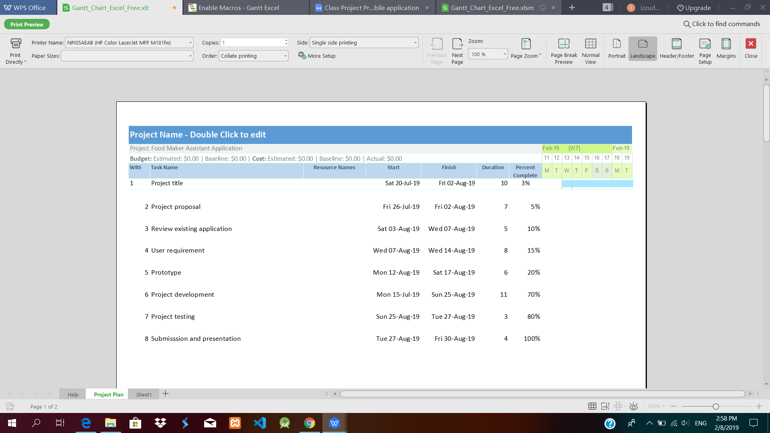

**Gantt Chart**

**1.7 SIGNIFICANCE OF THE PROJECT**

This application can help and assist user to search and choose the recipes they want to cook and also help to give clear instructions on how to have a better dishes. Users also can become a good chef as mostly the recipes came from the best chef. Users also can save their time to choose the best ingredients as this application is provided the best recipes for each dishes.

**1.8 SUMMARY**

Food Maker Assistant Application help and assist users to search, choose, provide clear information, give exact amount of items or ingredients per serving and give exact duration of time to cook the tasty dishes. It is important to cook good quality of dishes and users can cook the good quality of dishes or meals by using this application.

**FEATURES AND FUNCTIONALITIES**

|  |  |  |
| --- | --- | --- |
| Features and functionalities | Description | Person in charge |
| 1. User registration | User need to enter their email address and password as registration for their account. If not register yet, users need to create an account. | Izzuddin |
| 1. Home screen | User enter the main menu of the application and can see the top dish and also the recipe of the dessert. | Izzuddin |
| 1. Malay Screen | User enter the Malay dishes page and can see the list of dishes and the recipe there. | Izzuddin |
| 1. Western screen | User enter the Western dishes page and can see the list of dishes and the recipe there. | Izzuddin |
| 5.Video screen | User enter the video page and can see the tutorial video about making the dishes with the great chef and recipe. | Izzuddin |

**ENTITY RELATIONSHIP DIAGRAM**

The UML class diagram is based on the relationship of the difference table consists of User registration, Home, Malay, Western and Video.

|  |
| --- |
| User Registration |
| **PK UserID** |
| email  password |

|  |
| --- |
| Home |
| **PK UserID** |
| email  password |

|  |
| --- |
| Western |
| **PK UserID** |
| email  password |

|  |
| --- |
| Malay |
| **PK UserID** |
| email  password |

|  |
| --- |
| Video |
| **PK UserID** |
| email  password |

**1.9 REFERENCES**

1. Kitchen Stories., "From Your Desk To The Open Road, We Will Keep You Well Fed" Kitchen Stories., 2018. [Online].

Available: <https://www.kitchenstories.com/en>.

[2] Nasi Lemak Recipe, "Rasa Malaysia," 2018. [Online]. Available: <https://rasamalaysia.com/nasi-lemak-recipe/>